[HCM23_FRF.V_Devops_02] Docker_ Topic 4: Docker Compose

Task1: Create a simple web server using Docker Compose that runs a basic HTML page. Access the page from your browser
In our workdir we create 3 file: Dockerfile, compose.yaml, index.html for our web html:
Dockerfile
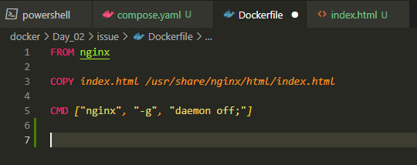
File index.html
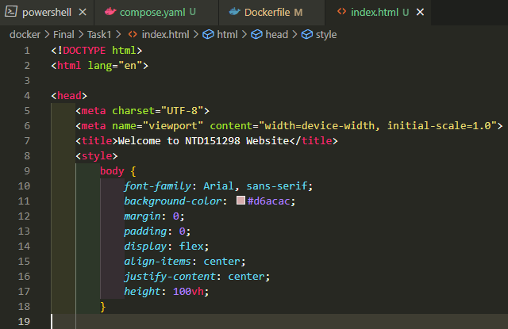
Compose.yaml ( with build and name to our container )
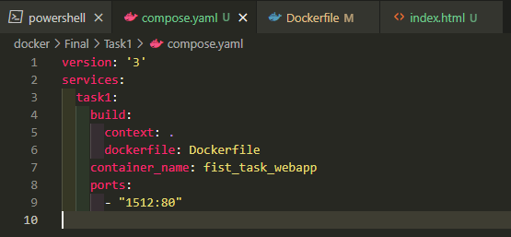
We using command docker compose up to build our docker file and deploy it to our container
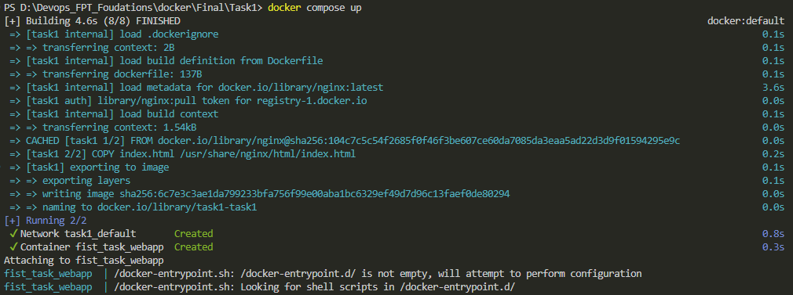
We then enter localhost:1512
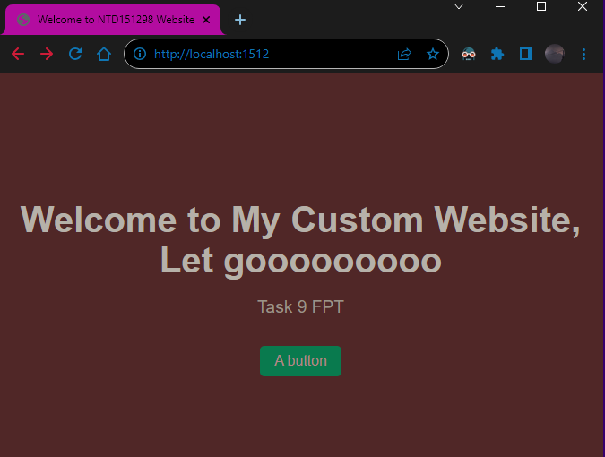

Task2: Create a Docker Compose file for a multi-container deployment: 1 container with nginx:1.22 image and 1 container with httpd:latestimage. Expose the above containers at 0.0.0.0:80 Ensure they can communicate
Fist we wirte our docker compose file with the deployment of 2 coantainer nginx and httpd port 80
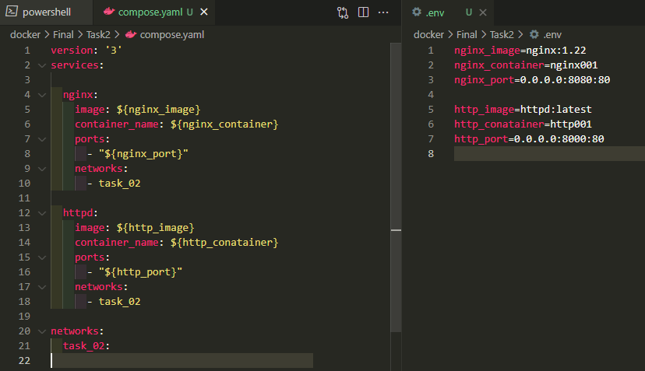
We using command docker compose up -d to start 2 of our conatainer
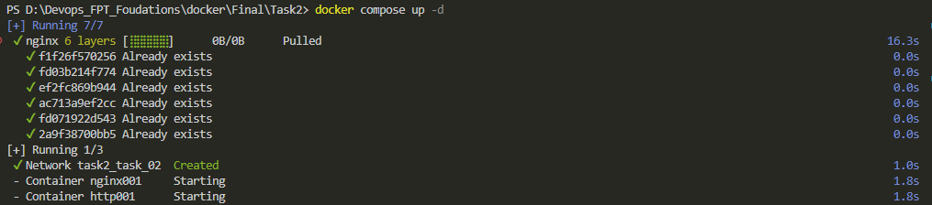
We have success expose httpd to port 8000 and nginx to port 8080
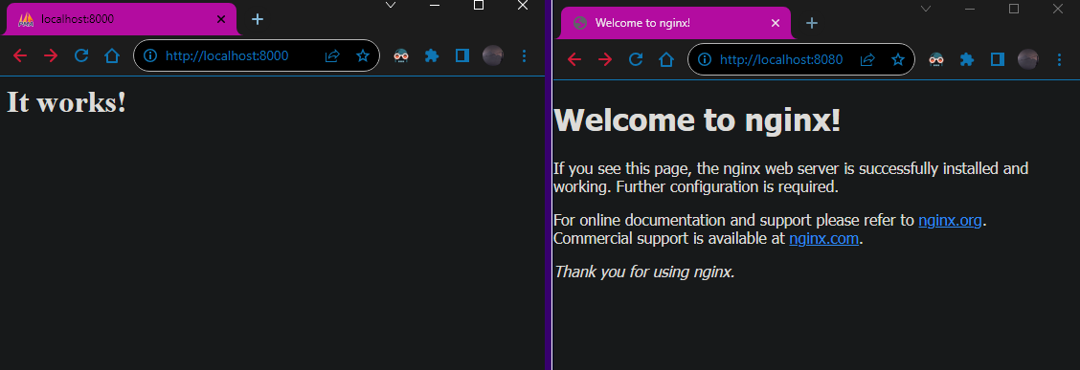
To ensure they can communicate we enter 1 of the running container
We enter nginx container
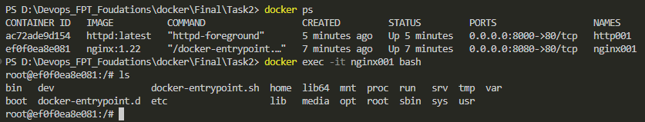
And then we call httpd conatainer with it domain name
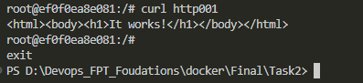
We also can inspect network of 2 conatainer we just create
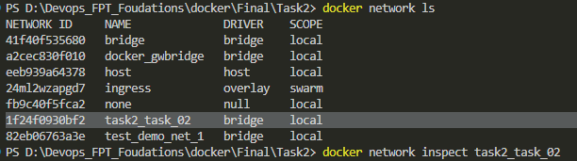
And find out them ip address within docker user bridge network and call them using their ip add
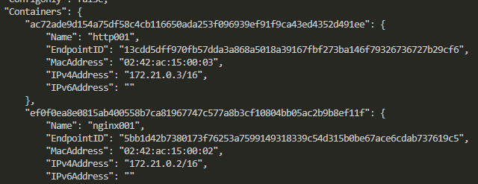
Call http using it’s ip address
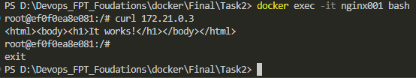

Task3: Use Docker Compose to set environment variables for the 2 container above: ENV=dev for both container; APP=frontend for nginxcontainer and APP=backend for httpdcontainer. Check if those variable are available in each container
We modify our compose.yaml file we create at task 2, we add enviroment config for nginx and httpd
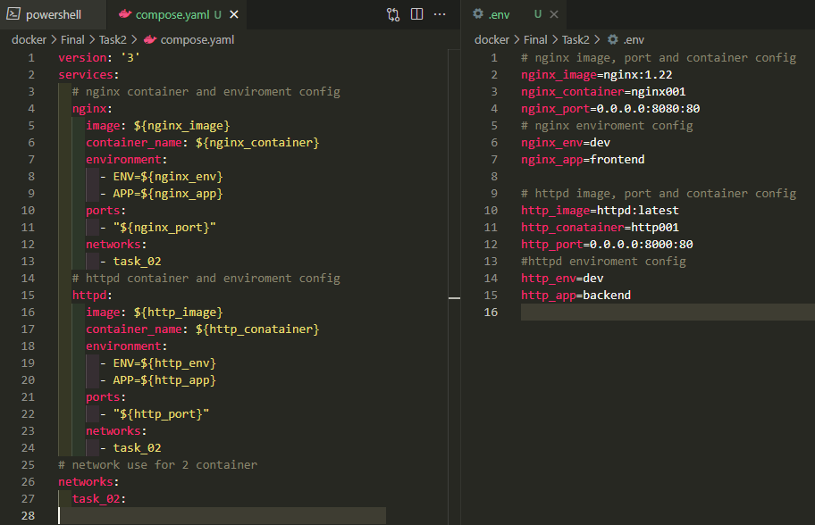
We then run new compose.yaml file
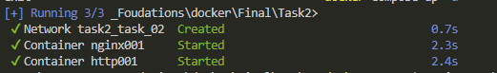
We enter nginx container to check enviroment variables we set
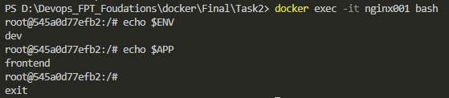
We do the same with httpd container and check enviroment variables we set
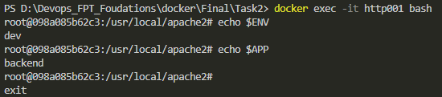

Task4: Set up a Docker Compose file that uses volume mounting: create a bind mount volume binding /tmpof the host filesystemand mount it to both of the container above at any location. Create a file named index.html in the /tmpof the host filesystemto see if it is available in both containerv
Fist we create tmpof folder from the host filesystemand with no file in it
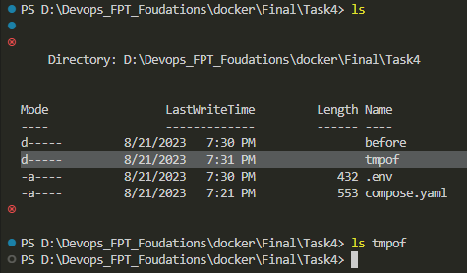
We set up a docker compose file that uses volume mounting: bind mount folder /tmpof from host filesystemand to folder that will display our web front page in 2 container nginx and httpd
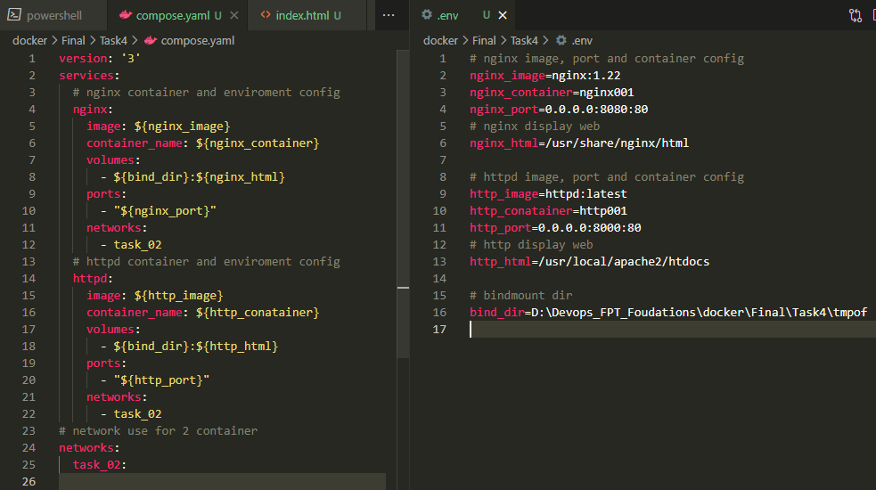
${bind_dir}=D:\Devops_FPT_Foudations\docker\Final\Task4\tmpof (host files folder)
${ nginx_html }=/usr/share/nginx/html (folder display nginx frontend web)
${ http_html }=/usr/local/apache2/htdocs (folder display httpd frontend web)
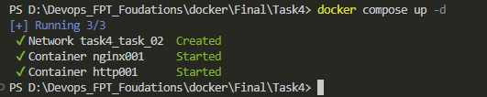
We fist check nginx and httpd web
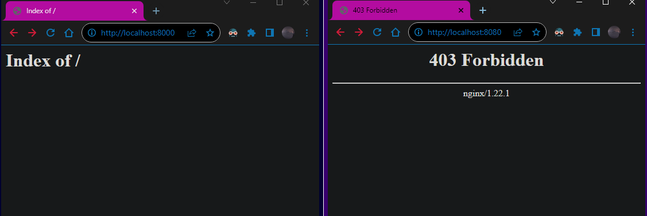
Folder that bind mount in 2 container
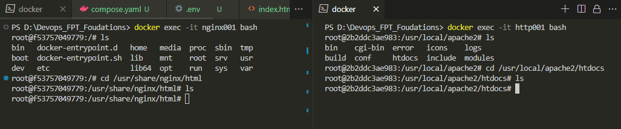
As you can see in the folder there is notthing to display
Now we create a html file
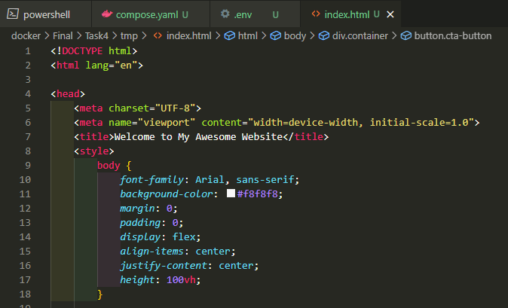
We then put the index.html file to /tmpof folder
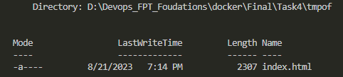
We recheck 2 container now
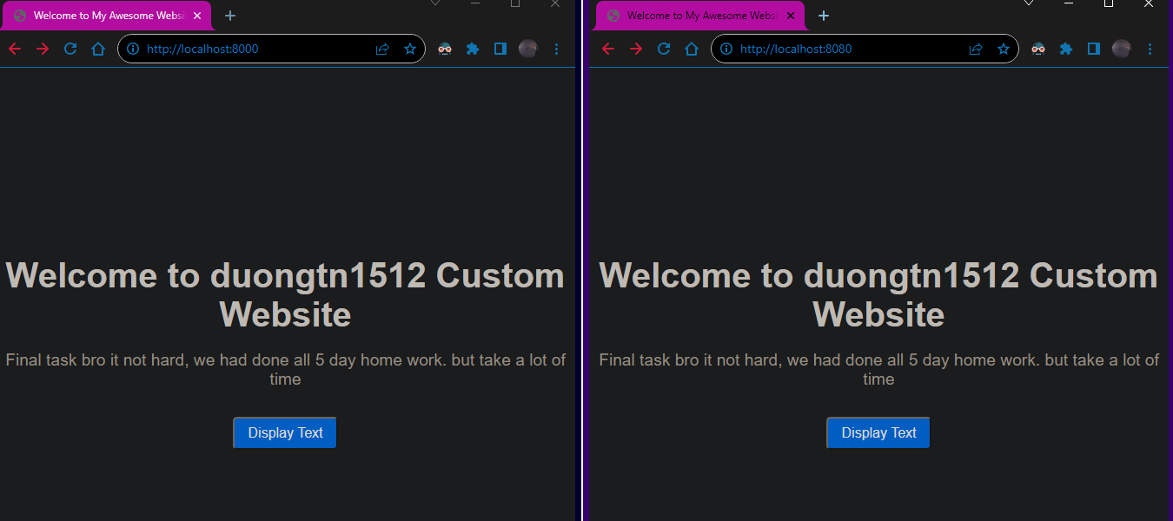
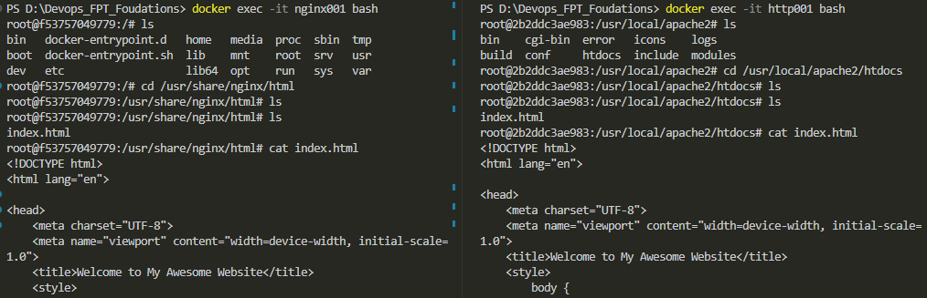
We add text.txt in the tmpof folder for frontend display text
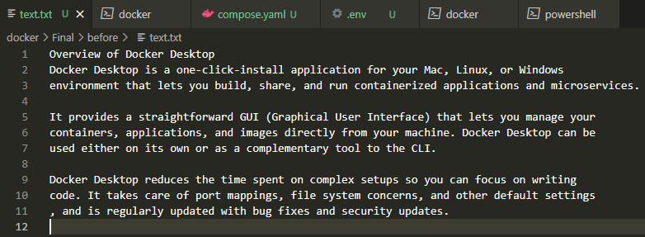
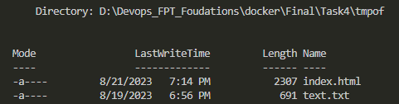
Now for our final check
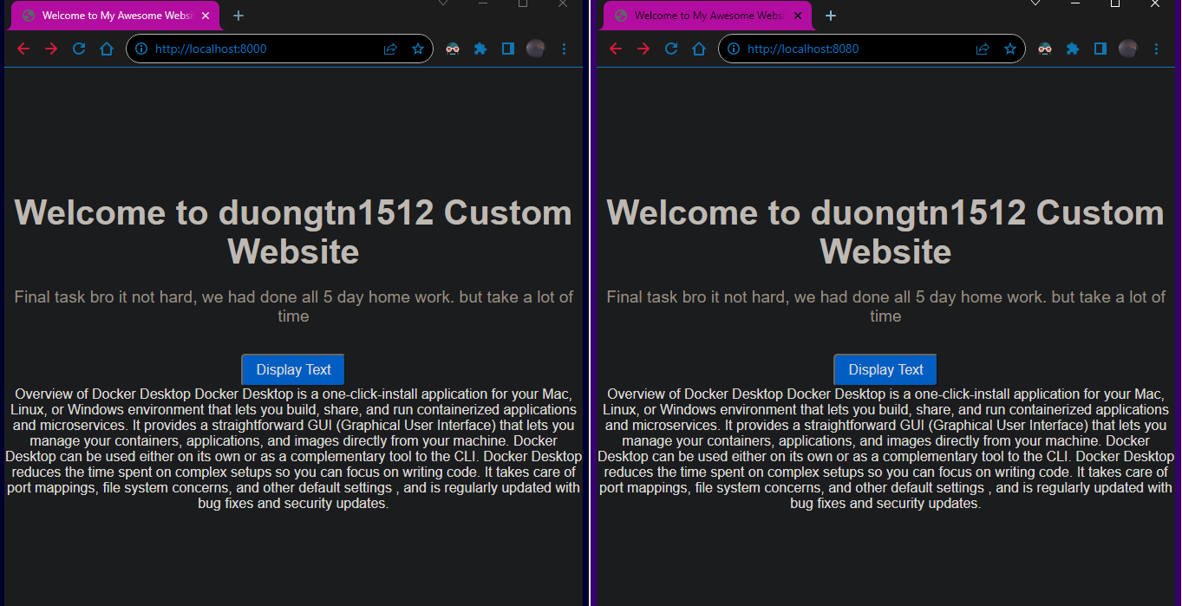
In conatiner
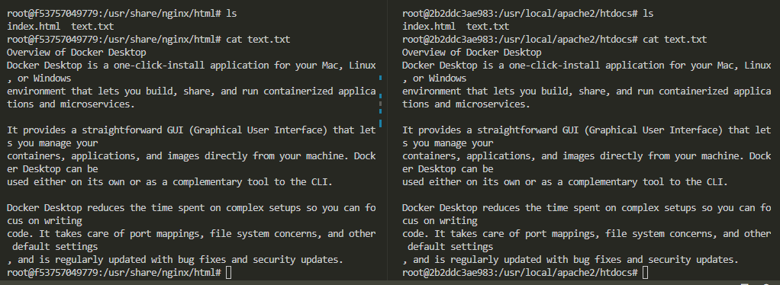

End.

